/*
=========================
======= Part 01 =======
=========================
*/

----------------------------------------------------------
1-- Create a database “by Wizard” named “RouteCompany”
----------------------------------------------------------
/*
Create the following tables with all the required information and load the
required data as specified in each table using insert statements[at least two rows]
*/

CREATE DATABASE RouteCompany

--------------------------------------------------------------------
---------------------- Department ------------------------
--------------------------------------------------------------------
CREATE TABLE Department
(
DeptNo VARCHAR(10) PRIMARY key ,
DeptName VARCHAR(50) NOT NULL,
Location VARCHAR(50) NOT NULL
)

INSERT INTO Department
(DeptNo , DeptName , [Location])
VALUES('d1' , 'Research', 'NY')
,
('d2' , 'Accounting', 'DS'),
('d3' , 'Marketing', 'KW')

--------------------------------------------------------------------
---------------------- Employee ------------------------
--------------------------------------------------------------------
CREATE TABLE Employee
(
EmpNo INT PRIMARY key ,
EmpFname VARCHAR(20) NOT null,
EmpLname VARCHAR(20) NOT null,
DeptNo VARCHAR(10) ,
Salary SMALLMONEY UNIQUE,
FOREIGN KEY (DeptNo) REFERENCES Department(DeptNo)
)

INSERT INTO Employee
VALUES

(25348 , 'Mathew' , 'Smith' , 'd3', 2500),
(10102 , 'Ann' , 'Jones' , 'd3' , 3000),
(18316 , 'John' , 'Barrymore' , 'd1', 2400),
(29346 , 'James' , 'James' , 'd2' , 2800),
(9031 , 'Lisa' , 'Bertoni' , 'd2' , 4000),
(2581 , 'Elisa' , 'Hansel' , 'd2' , 3600),
(28559 , 'Sybl' , 'Moser' , 'd1' , 2900)

--------------------------------------------------------------------
---------------------- Project ------------------------
--------------------------------------------------------------------

CREATE TABLE Project
(
ProjectNo VARCHAR(10) PRIMARY key ,
ProjectName VARCHAR(20) NOT null,
Budget money
)

INSERT INTO Project
VALUES
('p1' , 'Apollo' , 120000),
('p2' , 'Gemini' , 95000),
('p3' , 'Mercury' , 185600)

--------------------------------------------------------------------
---------------------- Work On ------------------------
--------------------------------------------------------------------

CREATE TABLE Works_on
(
EmpNo INT NOT NULL ,
ProjectNo VARCHAR(10) ,
Job VARCHAR(20) ,
Enter_Date date DEFAULT(GETDATE()) NOT NULL ,
PRIMARY KEY (EmpNo , ProjectNo),
FOREIGN KEY (EmpNo) REFERENCES Employee(EmpNo),
FOREIGN KEY (ProjectNo) REFERENCES Project(ProjectNo)
)

INSERT INTO Works_on
VALUES
(10102 , 'p1' , 'Analyst' , '2006.10.1'),
(10102, 'p3', 'Manager', '2012.1.1'),
(25348 , 'p2' , 'Clerk' , '2007.2.15'),
(18316 , 'p2' , NULL , '2007.6.1'),
(29346 , 'p2' , NULL , '2006.12.15'),
(2581 , 'p3' , 'Analyst' , '2007.10.15'),
(9031 , 'p1' , 'Manager' , '2007.4.15'),
(28559 , 'p1' , NULL , '2007.8.1'),
(28559 , 'p2' , 'Clerk' , '2012.2.1'),
(9031 , 'p3' , 'Clerk' , '2006.11.15'),
(29346 , 'p1' , 'Clerk' , '2007.1.4')

/*
------------------------------------
Testing Referential Integrity
------------------------------------
*/
------------------------------------------------------------------------------------------------------------------------
1- Add new employee with EmpNo = 11111 In the works_on table
[what will happen] => Error
------------------------------------------------------------------------------------------------------------------------
It is not possible because employee number 11111 is not present in the employee table

------------------------------------------------------------------------------------------------------------------------
2- Change the employee number 10102 to 11111 in the works on table
[what will happen] => Error
------------------------------------------------------------------------------------------------------------------------
It is not possible because employee number 11111 is not present in the employee table

------------------------------------------------------------------------------------------------------------------------
3- Modify the employee number 10102 in the employee table to 22222.
[what will happen] => Error
------------------------------------------------------------------------------------------------------------------------
It is permissible provided that the number 22222 is already present in the employee’s table

------------------------------------------------------------------------------------------------------------------------
-- 4 - Delete the employee with id 10102 => Error
------------------------------------------------------------------------------------------------------------------------
-- It is not permissible because employee number 10102 is present in a table
Works_on as a foreign key

-- The correct way is to delete all columns for my employee number 10102
from the table Works_on first

-- Secondly, delete employee number 10102 from the employee table

/*
-------------------
Table Modification
-------------------
*/
-- 1- Add TelephoneNumber column to the employee table[programmatically]

ALTER TABLE Employee
ADD TelephoneNumber VARCHAR(15)

-- 2- drop this column[programmatically]

ALTER TABLE Employee DROP COLUMN TelephoneNumber

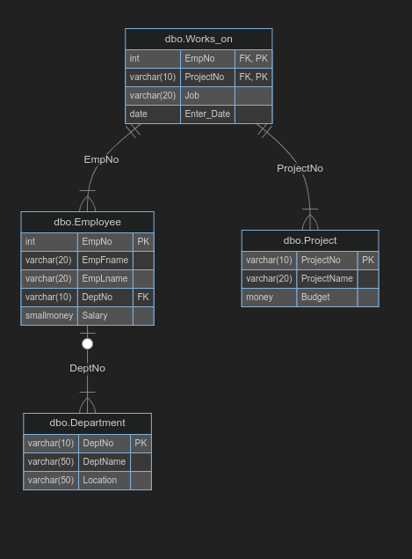
-- 3- Build A diagram to show Relations between tables

